[ Bhargav Ram Reddy ]

CS 428 - Project 1

* Source files have been well commented.

Sample Output:

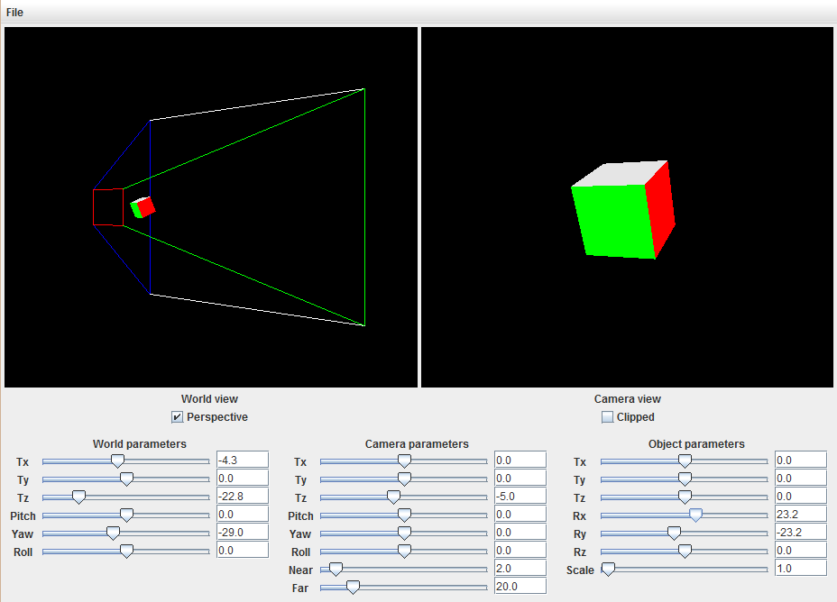

Methods completed or changed:

-----------------------------

Cube.java:

- transform()

To apply model transformation and push M onto stack

CameraView.java:

- projection()

This method handles window resizing, sets the camera projection transformation based on the aspect ratio. The projection type is either perspective or orthographic, it depends on Boolean Camera.isPerspective()

- draw()

This method draws the cube (by calling Cube.draw()), includes transformations(VM) by calling transformation methods

- transformation()

To apply camera view transformation

WorldView.java:

- projection()

This method handles window resizing, sets the world projection transformation based on the aspect ratio. The projection type is always perspective

- draw()

This method draws the view volume of camera and cube. Calls world transformation method, pushes inverse view transformation onto stack and pops, pushes model transformation and pops

glLoadIdentity();

W transform;

Push matrix()

V inverse transformation

Pop matrix()

Push matrix()

M transformation

Pop matrix()

- transformation()

Apply world view transformation W

ViewVolume.java:

- draw()

Draw Camera view volume by calculating vertices.

- placeClipPlanes()

This is called in WorldView.draw() method. In this method, placeClipPlane() method is called for 6 times(6 planes) passing 3 points of a plane.

- placeClipPlane()

Defines planes by calculating equation. Once the equation is calculated the corresponding planes are clipped by calling glClipPlane(plane, eqn,0) function.